**APRIL EXAM PERIOD 2022**

**April 18(Monday), 9:00, Amphitheater SILOS**

* 100 questions (min 51 correct answers to pass exam)
* Duration of exam: two hours (120 min)
* **Exam results** - Faculty website, **14.00, Tuesday, April 19**
* Exam results will be signed in indexes on **Wednesday, April 20, 12:00-13:00**, Lab of Parasitol-Mycol
* Stamp on mark/signature in index – Instutute of Microbiology (Dr Subotića 1), ground floor, Mrs Slavica Marjanović
* If you think you have **choose wrong answer**, you can mark another answer but **put your signature/initials BESIDE CORRECT ANSWER**

**CORRECTED ANSWER WITHOUT INITIALS WILL NOT BE ACCEPTED!**

* You can **correct a maximum of 7 questions**, 3 from bacteriology, 2 from parasitology-mycology and 2 from virology
* **Bringing indexes (identification) to the exam is compulsory !!!**
* **Be sure to bring fully completed white application form with you – also the back side**

**(full name, index number, and name of the subject – Medical Microbiology) !!!**

**(you can not fill application form inside amphitheater !!!)**

* **WEARING OF KN95 MASK IS STRONGY RECOMMENDED/MANDATORY** **!!!**

Best,

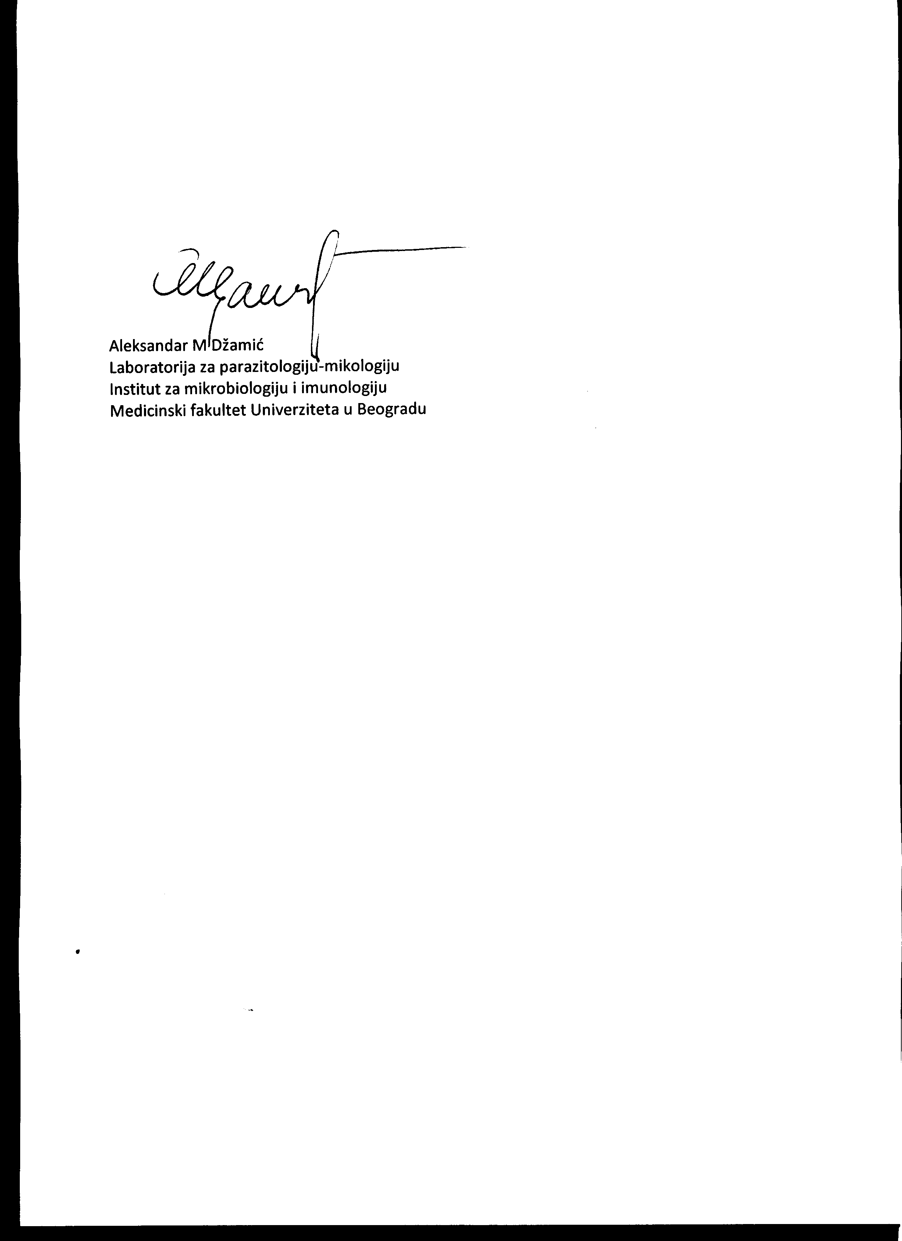

Prof AM Džamić April 15, 2022, Belgrade